1.3 sound

Class _____________ name______________

1. (a) Explain the sampling rate and sampling resolution.

(b) Explain how an analogue sound wave is sampled to convert it into digital format.

• Amplitude (of the sound wave) measured

• At regular time intervals

• Value of the sample is recorded as a binary number

(c) Give **one** reason why 16-bit sampling is used in an audio compact disc (CD).

1. (a) Fill in the vacancies in the following sentences：

• If samples are taken more frequently, the quality of the sound wave will ____________.

• If a ____________ number of bits is used to encode each sample, the sound resolution will increase.

(b) ``As long as the sampling rate is infinitely high, can the digital signal be infinitely close to the analog signal’’, is that true? Give an example to illustrate it.

1. A student is creating a short video and needs to record music to play in the background.

(a) The student uses a microphone to capture the music. Explain how the microphone captures the music.

(b) The student uses sound editing software to edit the sound file. Name **two** features of sound editing software the student can use to edit the sound file.

Describe the purpose of each feature.

Feature 1

Purpose

Feature 2

Purpose

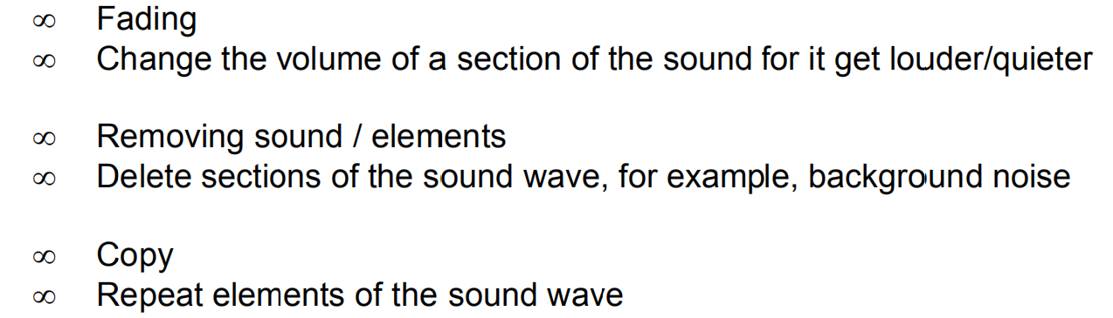

1. Sample the sound wave below and convert it into binary form.

